Laurence R. Martin | Joseph A. Soueidi
Jeffery A. Hunnes | Roberta A. Berkhof
Jeffrey A. Weldon | Ryan A. Stewart
Martin S. Smith | Nyles G. Greer
Of Counsel:
Joel E. Guthals | Mary E. Duncan
jweldon@feltmartinlaw.com


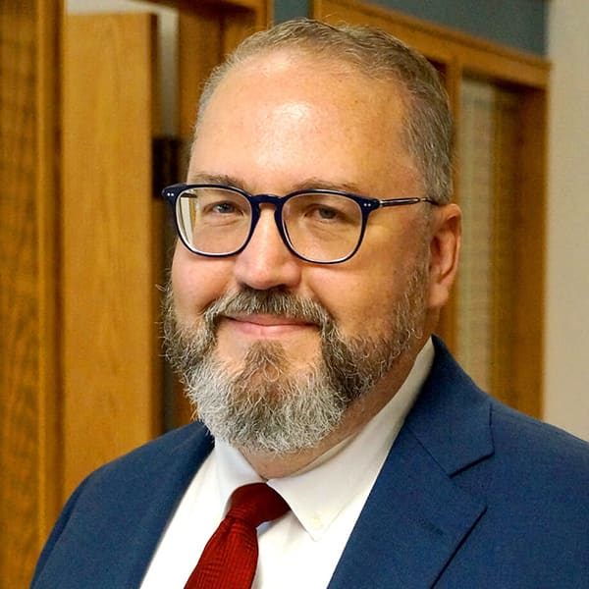
Jeffrey A. Weldon

Jeff joined the firm in 2005 and is a shareholder. His practice primarily focuses on Montana school law, labor and employment law, and local government law. Jeff serves as general counsel for several Montana school boards and has advised and represented other public and private entities. Jeff serves as the City Attorney for the City of Forsyth, Montana.

He formerly served as legal counsel and human resources director for Billings Public Schools, Montana’s largest public school system. He also served as chief legal counsel for Montana’s Superintendent of Public Instruction. He was formerly associated with the law firm of Moulton, Bellingham, Longo & Mather, P.C., in Billings.

Jeff served in the Montana Senate from 1993 to 1997, during which time he served as a member of the Senate Local Government Committee, the Senate Natural Resources Committee, the Montana Reserved Water Rights Compact Commission, the Montana Environmental Quality Council, and the Montana Indian Affairs Committee.

Jeff lives on the family ranch south of Billings with his wife, Leslie, and a house full of dogs and cats. Jeff and Leslie have two daughters.

Nyles G. Greer

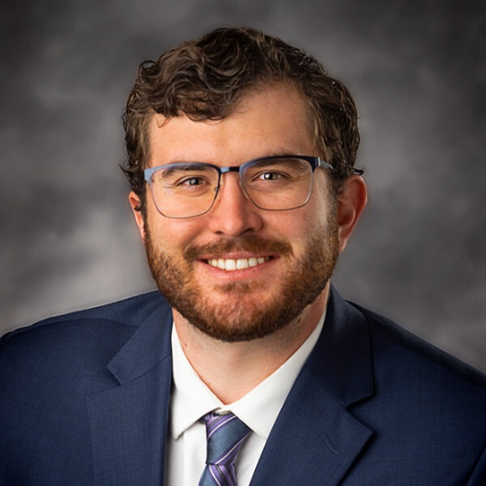
Nyles joined Felt Martin in 2023 as an Associate Attorney, and he has been practicing in Montana since 2020. During law school, Nyles was a staff member of the Public Lands and Resources Law Review and had the privilege of being a summer law clerk for the Honorable Mary Jane Knisely. His practice primarily focuses on Montana school law, labor and employment law, and local government law. Nyles serves as the Deputy City Attorney for the City of Forsyth, Montana.

As a lifelong Montanan, Nyles enjoys being able to practice near his hometown as well as partake in typical Montana hobbies including fishing, hunting, and camping. He resides in Billings with his wife, Abbie, and their dog, Wayne.

